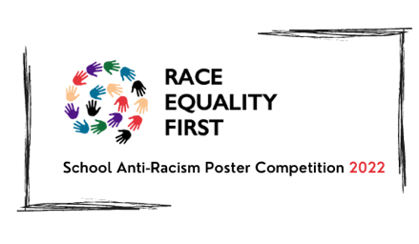

The Race Equality First School Anti-Racism Poster Competition 2024
Information Pack

“The youth of today are vital in ensuring we have an anti-racist Wales in the years ahead” – Aliya Mohammed, CEO, Race Equality First

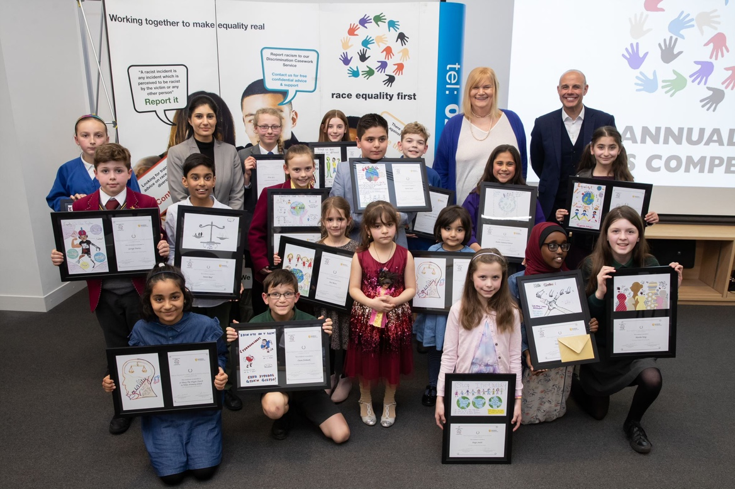

Thank you for your interest in the Race Equality First School Anti-Racism Poster Competition!

This information pack includes the following:
- A list of Frequently Asked Questions
- Official press release - please feel free to include this information in your school newsletter or on your website (separate attachment)
- PDF of the competition poster – for you to print out and include on your school notice board if you’d wish to (separate attachment)

If you have a question that is not covered here, please email zainab@raceequalityfirst.org.uk or call 029 2048 6207

The 2024 Race Equality First School Anti-Racism Poster Competition – Frequently Asked Questions

Q1. Why do Race Equality First run an anti-racism poster competition?
A1. Race Equality First is a charity founded in 1976 as one of the original race councils of the devolved nations. We support victims of discrimination and hate crime and encouraging young people to be aware and more involved in promoting equality is just one way we work with school pupils to open the discussion of what racism is, how important it is to be anti-racist and that equality matters.

Q2. Do you have any guidance on how to include the poster competition within the school day?
A2: From previous years, we know that most schools use one lesson session to encourage their pupils to create the poster. Some schools with dedicated art teachers have created work over several weeks. Some schools have included the information on their school newsletter and children have created posters at home with their parents and brought them into school to share and discuss. Or you may have your own way of including it in your school topics and planning.

Q3: Do entries need to be a specific size?
A3: Entries can be any size.

Q4: Can the pupils use any medium/materials?
A4: Yes, as this is a poster competition, any 2D work that can be scanned is encouraged and drawings, paintings, collages, digital artwork and photography projects are allowed.

Q5: Are group entries allowed?
A5: Yes, however each entry will be treated as a single poster so prize winners would share the final prizes if they won.

Q6: Is there anything that is not allowed?
Q6: As this is a competition by Race equality First, we encourage the use of the theme for this year; Racism Stops With Me or our charity name ‘Race Equality First’ within the artwork. Other campaigns such as Black Lives Matter are allowed but using other charity or organisation names are discouraged and may not be included in the judging.

Q7: How do we submit or prepare entries to send in?
A7: Please include the child’s name, age and name of school on the back of the artwork. If parents would prefer to keep their child’s name off any public posts, please include ‘No social media’ against their name. By including their name without this statement, you are confirming that the child’s name is permitted to be used when sharing competition winners and in any other competition publicity.

Q8: Can pupils send in more than one entry?
A8: Yes.

Q9: My child is home-schooled; can they enter the competition?
A9: Yes, the poster competition is open to all school age children.

Q10: Can the posters be in Welsh?
A10: Absolutely. The competition will run in both English and Welsh and students have the option to apply in either English or Welsh, or bilingually.

Q11: How do we submit the posters?
A11: We would prefer registered postal or drop off to the REF office. Cardiff collection may be possible from some areas, please email zainab@raceequalityfirst.org.uk to find out if your area may be covered for collection.

Please arrange to send the posters to:
Poster Competition
Race Equality First
113-116 Bute Street
Cardiff CF10 5EQ

Q12: What do the winners receive?
A12: Winners will receive a £50 Love 2 shop voucher, a framed print of their poster and certificate, a goodie bag and the opportunity to have their work included in other work. In previous years this has included a billboard campaign and a calendar featuring the winning posters. The winning schools will also receive a framed poster and certificate to display on school premises (South Wales and Gwent regions).

Q13: Your poster mentions a book bundle for the school that sends in the greatest number of entries. Can you tell me more about this?
A13: We know and understand how much representation matters in literature. This past year we have seen many new books being released that include characters from diverse backgrounds, as well as books that include ethnic minority history in the UK. To celebrate the 26th year of the poster competition, the school that sends in the greatest number of entries will receive a diversity and equality book bundle worth £250 for their school. This bundle will be tailored to either primary age or secondary age children depending on the winning school.

Q14: Who will be choosing the winning posters?
A14: A panel of a combination of trustees, staff and volunteers.

Q15: When is the deadline for entries and when will we be notified of the winning entries?
A15: The closing date is Thursday 18th April 2023 and winners will be notified by the first week of May 2023.

Q16: When is the awards ceremony?
A16: The awards ceremony will take place at Portland House Banking Hall in Cardiff Bay. The awards ceremony will be hosted by friend and patron of the charity, radio and TV personality Jason Mohammad.

If you have a question that is not covered here, please email zainab@raceequalityfirst.org.uk or call 029 2048 6207.

