Premier League Primary Stars: Feb Recruitment email

Email Contact Types: Heads, PSHE Leads, English Leads - High/ Low pupil premium split
Broadcast Date: 21 February 2023
From name: Premier League Primary Stars
Subject line:
A: Join a webinar and WIN a school Trophy visit!
B: 👉 Ask an expert: Join us for a FREE webinar 👈
Preview text: Events & resources to celebrate World Book Day
Hi @Firstname@,
We’re launching a series of brand new webinars to equip you to confidently speak with your pupils on topics worth discussing in your English lessons. By simply signing up and attending one of our webinars, you’ll be entered in the prize draw for the chance to win a Premier League Trophy visit for your school.
In this series of webinars, using the power of football to inspire positive conversations, a panel of teachers and industry experts will provide insight and tips that will enable you to feel confident discussing important topics such as; anti-discrimination, diversity and maths anxiety. Panellists include experts from BAMEed Network, Stonewall and Bobby Seagull!
Research shows that 94% of teachers want anti-racism training,* so our first webinar will be about Celebrating Diversity and how to speak confidently on race, using the power of football to ease pupils into open conversations. Sign up now and mark 7 March in your diary!
[Sign up for FREE]

Along with these new webinars, we have plenty more FREE resources for your English lessons, including new resources to celebrate World Book Day on 2 March. See how your school can benefit from Premier League Primary Stars - all at absolutely no cost:
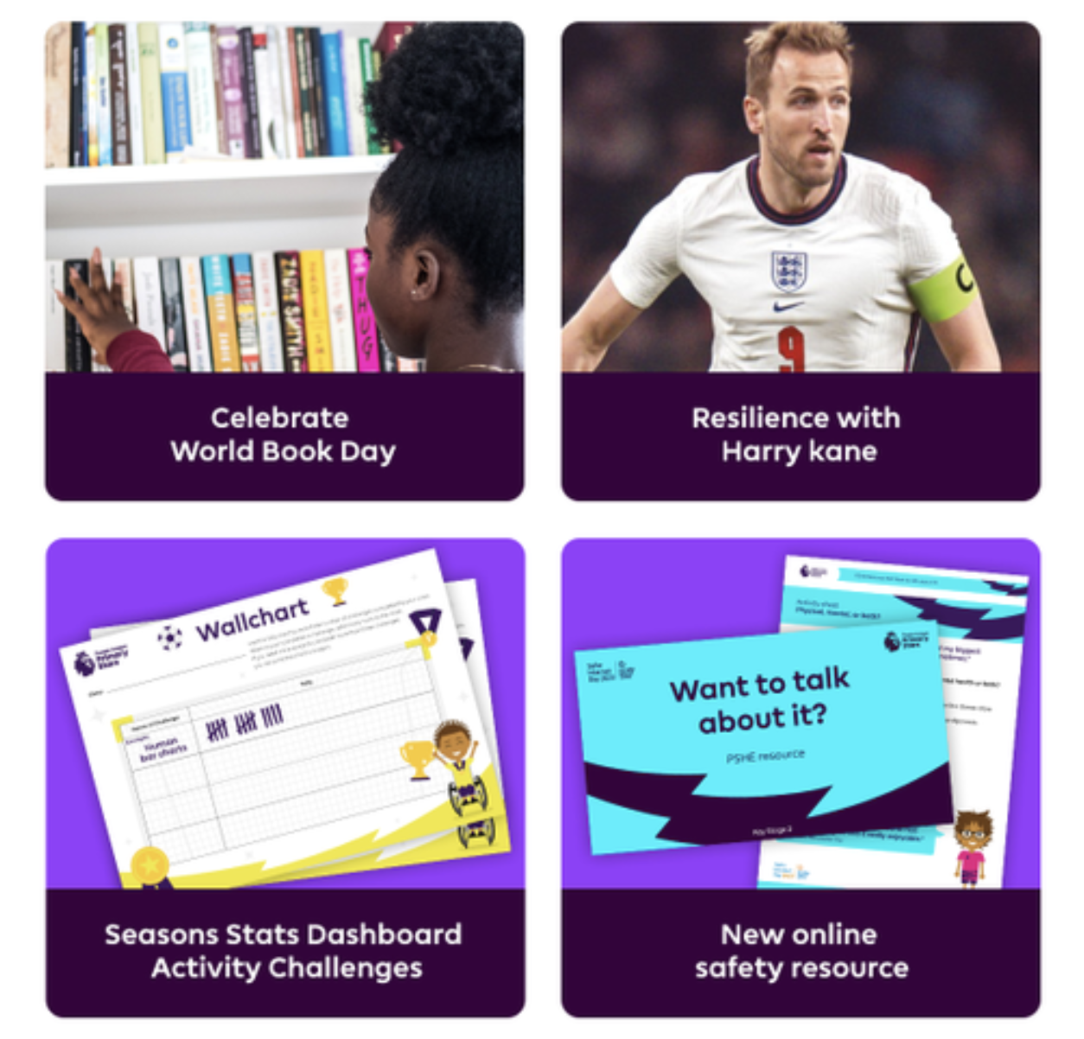

Let us ‘Pitch’ you our Resource Library
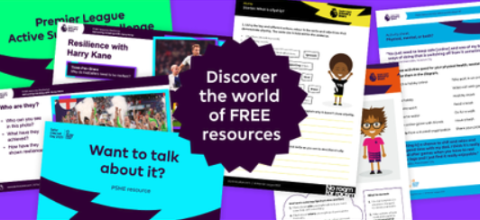
There’s a reason why 97% of teachers are satisfied with Premier League Primary Stars resources.** Our library full of flexible, ready-made teaching resources is suitable for learning throughout the year, across a range of subjects, and is always free.

[Discover FREE Resources]

[Footer]
* https://www.educationsupport.org.uk/media/painjg2z/mental-health-and-wellbeing-of-ethnic-minority-teachers.pdf
** https://plprimarystars.com/about/plps-impact-report
[PLPS Footer copy & social links]

