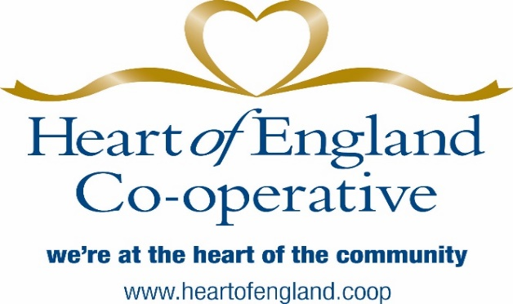

HEART OF ENGLAND CO-OPERATIVE SOCIETY

‘DESIGN A CHRISTMAS CARD’ COMPETITION

‘WHAT CHRISTMAS MEANS TO YOU’

How to Enter
- Entrants must be aged between 8 and 11.
- Designs should be on a sheet of maximum size A5.
- The theme is ‘What Christmas Means to You’ and must feature the Heart of England Co-operative logo which can be found on the top of the company letterhead.
- Designs should be original (not traced or computer generated) and produced freehand in crayon, paint (water colour, poster or acrylic), colour pencil (blended), Mono Tone (pencil) or combination of the above.
No additional materials such as foil paper, cotton wool or glitter should be used otherwise entries will be disqualified. Computer generated designs will also be disqualified.
- Name of child, school and age should be printed on the back of the entry countersigned by a teacher.
- Judges will be looking for creativity, originality and the ability to reproduce the card in a printed format. The judges’ decision is final.
- The deadline for submission of entries is 14th November 2018.
- The winner and runners up will be notified during week ending 23rd November with presentations thereafter.
- Prize for the winning school is £500 and £250 for the other two school finalists. The winning child and other two finalists will also receive cinema vouchers.
- Entries to be produced in school and limited to one per child. There is no limit to the number of entries per school.

